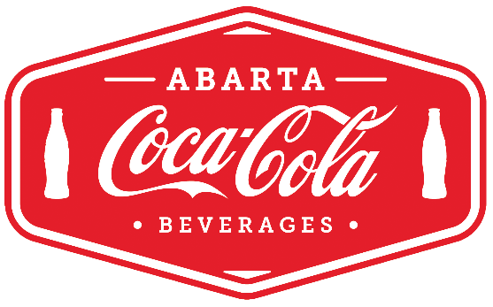
Product Donation Request Instructions

All product donations must be requested in writing on company/organization letterhead at least 2 weeks prior to the date needed. If the request is being made by a charitable organization, please also include a completed tax exemption form.

Your request should include your company/organization name, event location, date, type of event you are having, expected number of participants, expected audience (children/adults) and what products you would like to have donated. Please also include your name and contact information.

Please submit your request to the ABARTA Coca-Cola facility servicing your location:

Location Phone Email Address
Cleveland, OH (216) 378-7400 trusnak@abartacoacola.com 25000 Miles Road, Bedford Heights, OH 44146
Erie, PA (814) 833-0101 llee@abartacocacola.com 2209 W 50th St, Erie, PA 16506
Houston, PA (724) 745-4725 amcclain@abartacocacola.com 300 Vandale Dr, Houston, PA 15342
Greensburg, PA (724) 834-2700 jpietryga@abartacocacola.com 363 Donohoe Road, Greensburg PA 15601
Ebensburg, PA (814) 472-6112 emachuta@abartacocacola.com108 Barefoot Road, Ebensburg PA 15931
Harrisburg, PA (717) 730-2100 mkoons@abartacocacola.com 230 South 10th St., Lemoyne, PA 17043
Reading, PA (610) 916-3996 mrodriguez@abartacocacola.com 243 Snyder Road, Reading, PA 19605
Lancaster, PA (717) 393-0631 vihaas@abartacocacola.com 1428 Manheim Pike, Lancaster, PA 17601
Bethlehem, PA (610) 866-8020 jminnich@abartacocacola.com 2150 Industrial Dr, Bethlehem, PA 18017
Mt. Pocono, PA (570) 839-6706 aslynn.diaz@abartacocacola.com 319 Industrial Park Dr, Mt. Pocono PA 18344
Pittston, PA (570) 655-2874 mlussi@abartacocacola.com 300 Oak St, Pittston, PA 18640

